**Project Devlepment**

|  |  |
| --- | --- |
| Team ID | PNT2022TMID11590 |
| project | Containment Zone Alert Application |

**Delivery of Sprint-1**

**Step-1:Install Python 3.9.6,pip.IDLE**

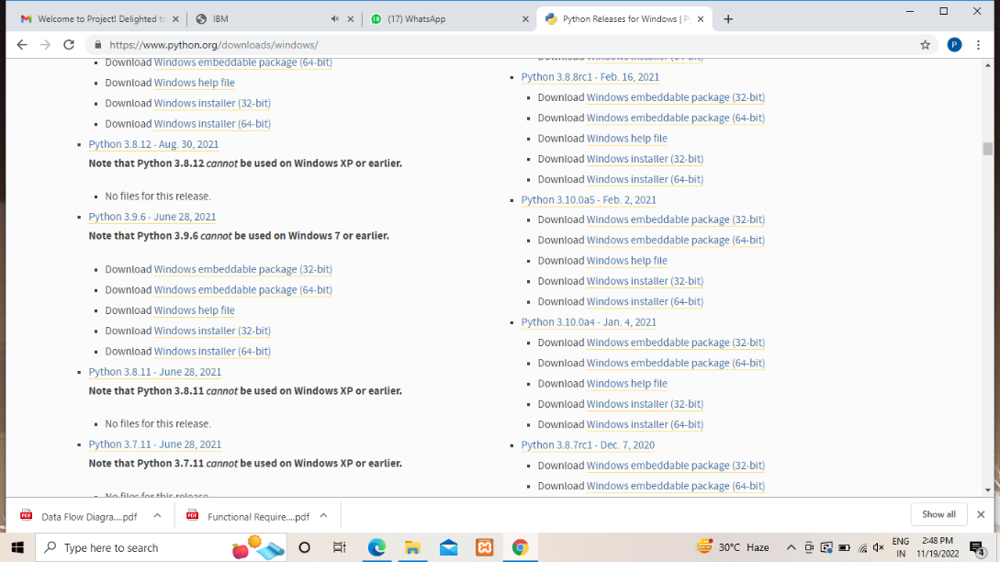

**Step-2:Verify Installation and checked on idle**

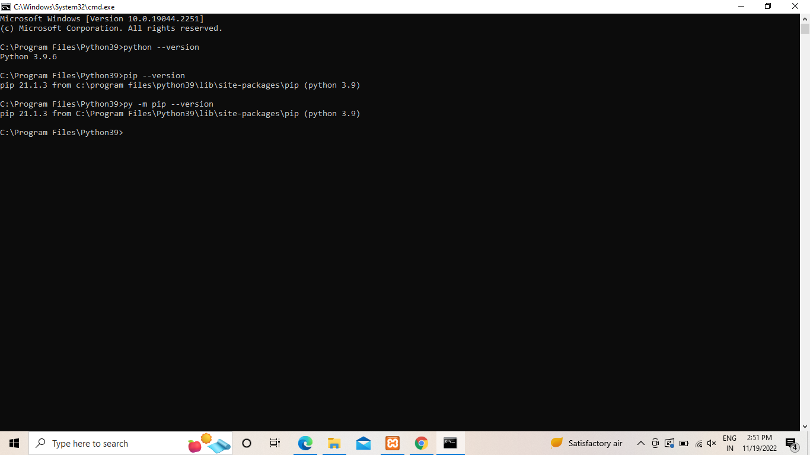

**Step-3:Install Flask**

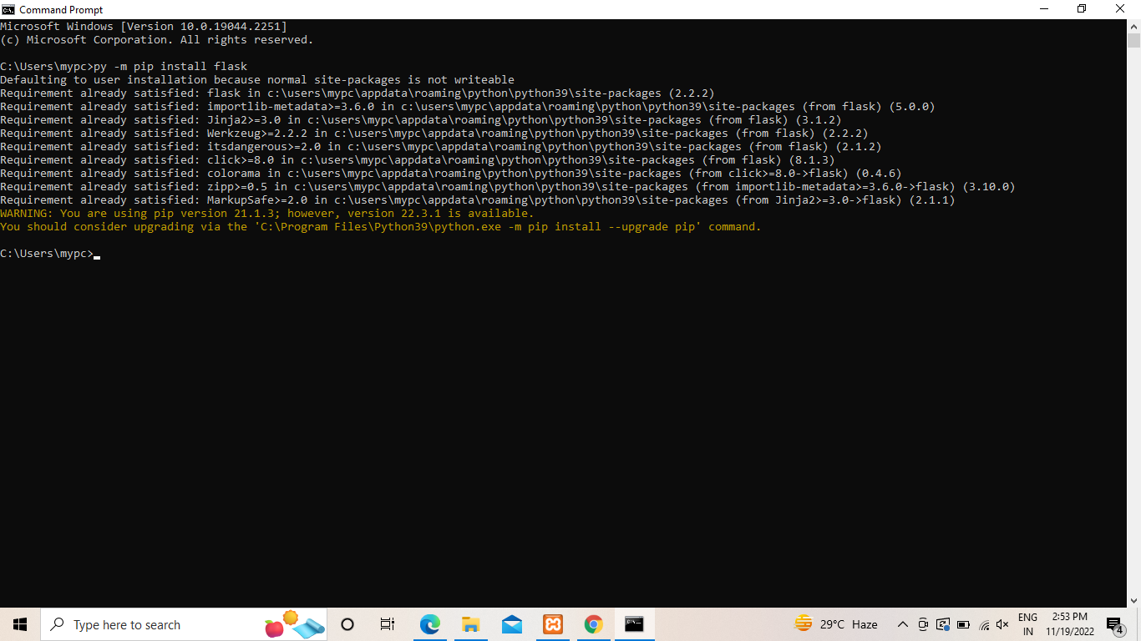

**Step4:Check it on IDLE**

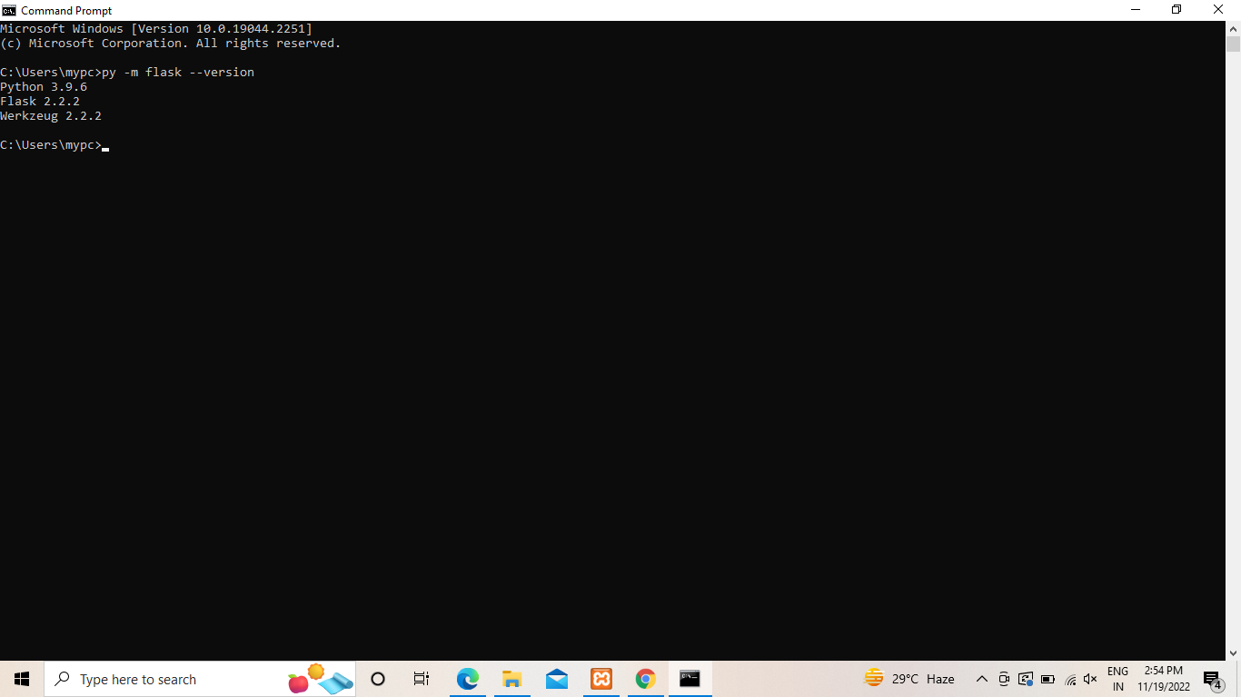

**Step-5:Print Flask version**

